**ADVANCED DATABASE MANAGEMENT SYSTEMS**

**ByteXL Practice Assignemnt-1**

1)Problem Statement no.1:

Design a basic book management system with two tables: authors and books.  
The relationship is one-to-many:  
→ One author can write multiple books.  
You must use primary and foreign key constraints to maintain data integrity.

CODE:

-- Creating Authors table

CREATE TABLE authors (

author_id INT PRIMARY KEY,

name VARCHAR(50),

country VARCHAR(50)

);

-- Creating Books table with foreign key reference to authors

CREATE TABLE books (

book_id INT PRIMARY KEY,

title VARCHAR(100),

author_id INT,

FOREIGN KEY (author_id) REFERENCES authors(author_id)

);

-- View structure of the tables

DESC authors;

DESC books;

SCREENSHOT OF OUTPUT:

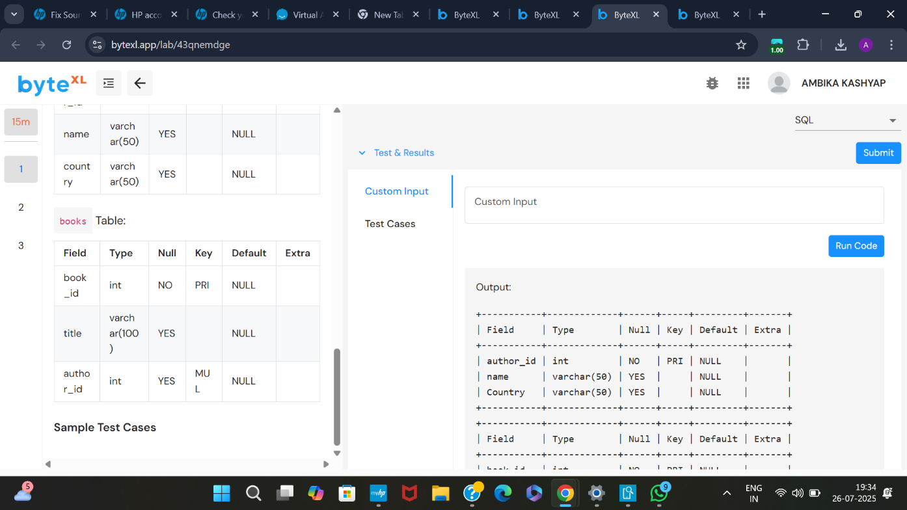

TEST CASE: PASSED

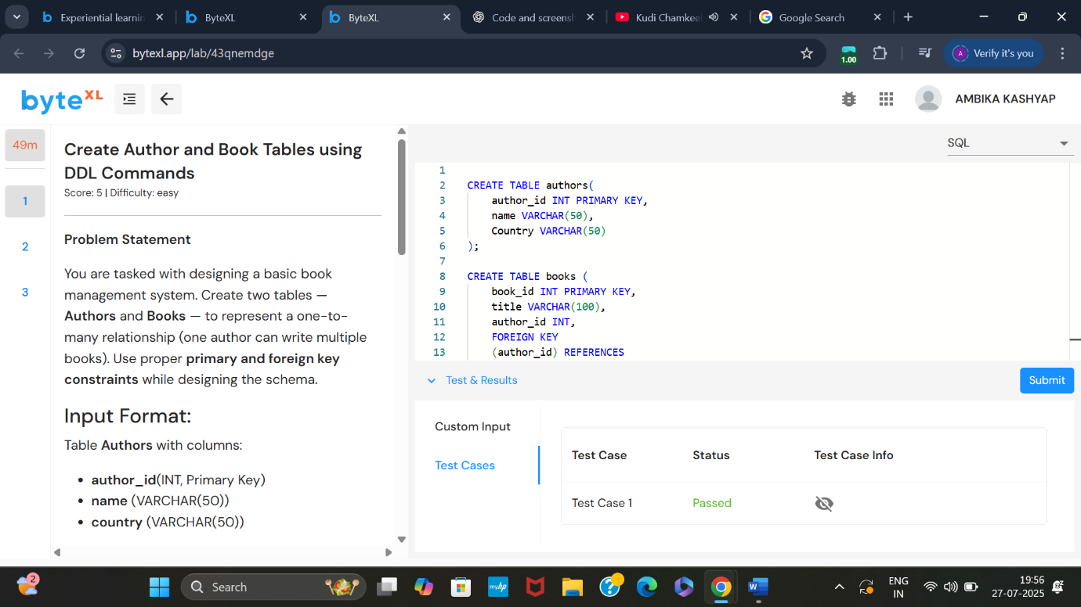

2)Problem statement no.2:

After creating the authors and books tables with appropriate constraints, insert **sample records** into both tables.  
Ensure that:

* Each **book references a valid author_id** from the authors table (one-to-many relationship).
* Use the INSERT INTO command correctly.

CODE:

-- Inserting sample authors

INSERT INTO authors (author_id, name, country)

VALUES

(1, 'Ashish', 'India'),

(2, 'Smaran', 'USA'),

(3, 'Vaibhav', 'UK');

-- Inserting sample books

INSERT INTO books (book_id, title, author_id)

VALUES

(101, 'Data Science Basics', 1),

(102, 'AI in Education', 2),

(103, 'SQL Simplified', 1);

-- View records from both tables

SELECT * FROM authors;

SELECT * FROM books;

SCREENSHOT OF OUTPUT:

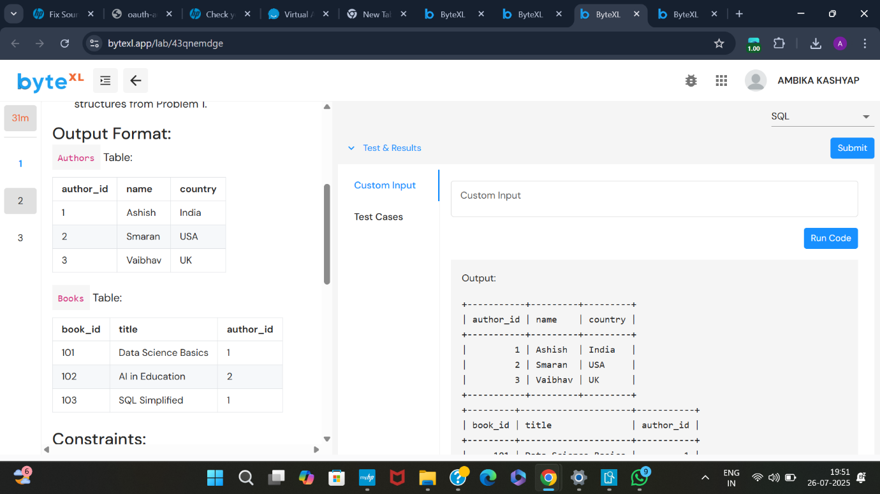

TEST CASE: PASSED

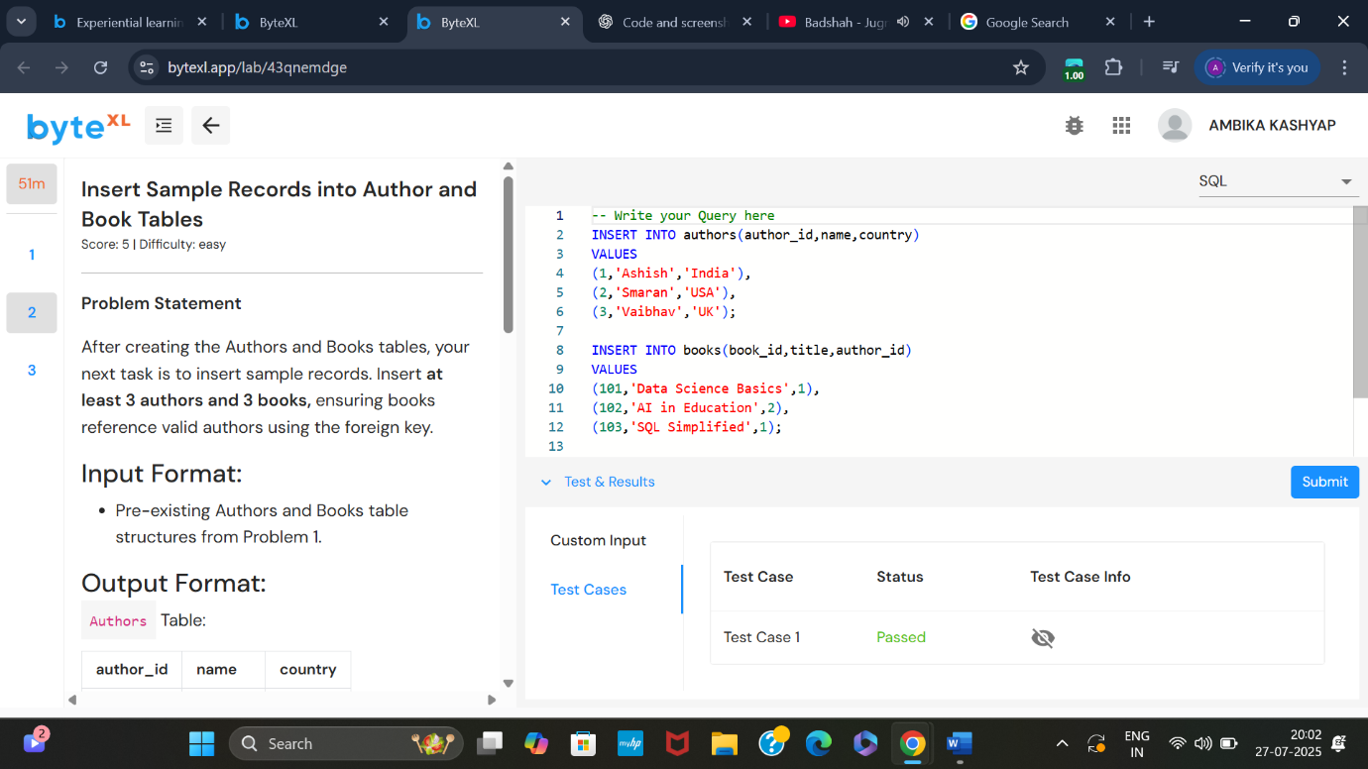

3)Problem statement no.3:

Given two tables: Authors and Books, retrieve the **titles of all books** along with their **author’s name and country**.  
Use an INNER JOIN on author_id to combine related records from both tables.

CODE:

-- Retrieve book titles with author name and country using INNER JOIN

SELECT

B.title,

A.name AS name,

A.country

FROM

Books AS B

INNER JOIN

Authors AS A ON B.author_id = A.author_id;

SCREENSHOT OF OUTPUT:

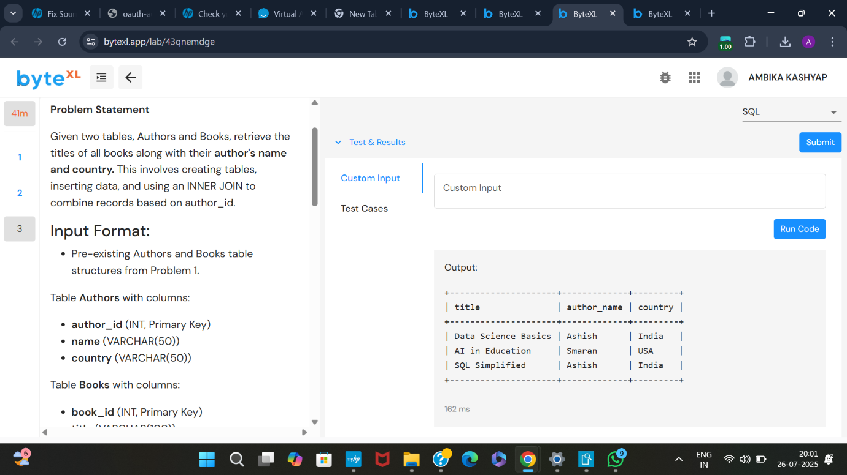

TEST CASE: PASSED



